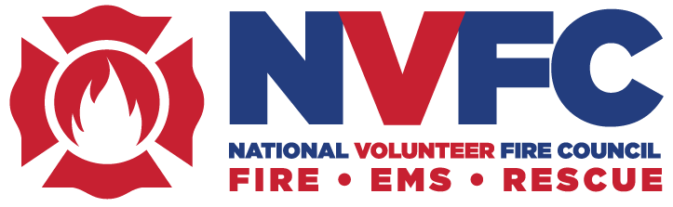

NVFC Holds Fall Meeting in Kansas City, MO

The National Volunteer Fire Council (NVFC) Board of Directors held its annual fall meeting on September 18-20 in Kansas City, MO. The board gathers as a whole twice a year to conduct Council business, guide the strategic direction of the organization, and vote on matters before the board. Among those in attendance were 64 directors from 41 states, including Ret. Chiefs Kevin Quinn and Mark St. Pierre from Rhode Island.

The three-day agenda included committee meetings, guest speakers, general and executive sessions, activities, and a special election. The following are the fall meeting highlights.

Committees Meetings

Many NVFC committees met during the fall meeting, along with the Council’s EMS/Rescue Section. The NVFC has 19 committees that steer the Council’s direction in critical areas including health, safety, and training; wildland; standards and codes; recruitment and retention; hazmat response; and more. (Quinn serves on the Health, Safety. & Training Committee, along with the Legislative and Codes & Standards Committee. And St. Pierre serves on the legislative Committee along with the Volunteer Advocacy Committee and Bylaws Committee.) The NVFC’s OSHA Task Force also provided an update on the proposed Emergency Response Standard. For more information on this standard, visit the NVFC landing page.

Board Actions

During a special election, Reid Vaughan (AL) was elected to the position of Second Vice Chair, and Joseph Maruca (MA) was elected to the Executive Committee. Regular elections will be held in the spring of 2025.

In addition, NVFC Chair Steve Hirsch presented Maruca and OSHA Task Force Chair David Denniston with the Chairman’s Award in recognition for their work in addressing the proposed OSHA Emergency Response Standard and raising awareness to OSHA, Congress, responders, and the public of the impact this standard would have on the volunteer fire service.

The board voted to make the New Mexico State Fire Marshals Office a state member of the NVFC. State members have the ability to appoint up to two directors to the NVFC. With this addition, the NVFC will now have 48 states represented on its board of directors.

The board also voted to add the Honoring Fallen Heroes Act to the NVFC’s legislative priorities. This act would provide Public Safety Officer Benefits for exposure-related cancer.

Guest Speakers

On September 19, the board heard a panel discussion on “Railway Safety and Volunteer Fire Departments: Best Practices and Collaborative Solutions,” which highlighted ways railroads and volunteer fire departments can work together to better prepare for and respond to railway incidents. Facilitated by the NVFC’s Ryan Woodward, the panel included Bob Clatterbuck of NTSB, Andy Elkins of the Association of American Railroads, Derek Lampkin of BNSF Railway, and Lane A. Sekavec of Union Pacific Railroad.

MacKenzie Pfeiffer gave a power presentation on September 20 titled “Breaking the Stigma: Embracing Mental Health and Self Care.” Drawing on her own personal heartbreak, Pfeiffer delved into why mental health is important in the fire service, the impact sigma has on individuals and communities, self-care strategies to improve mental wellbeing, and guidance to create personal action plans for individuals and departments.

Tom Jenkins of UL Fire Safety Research Institute provided an update on the status of the National Emergency Response Information System (NERIS), which will replace NFIRS.

Special Events

The Kansas City Fire Museum opened its doors for the NVFC board on the evening of September 18. The Chair’s Lunch was held on September 19. Later that evening, the board attended a reception and dinner followed by the annual auction to benefit the NVFC Health & Safety Fund.

Sponsors

The NVFC thanks the fall meeting sponsors for their support: Anheuser-Busch Foundation, BNSF Railway, Clarion Fire & Rescue Group, Columbia Southern University, ESIP, Firefighters Association of Missouri, National Fire Protection Association, OnStar, Provident, Tesla, Tractor Supply Company, and Wendell’s Mint.

Next Meeting

The next NVFC meeting will be held in Alexandria, VA, on May 8-10.

